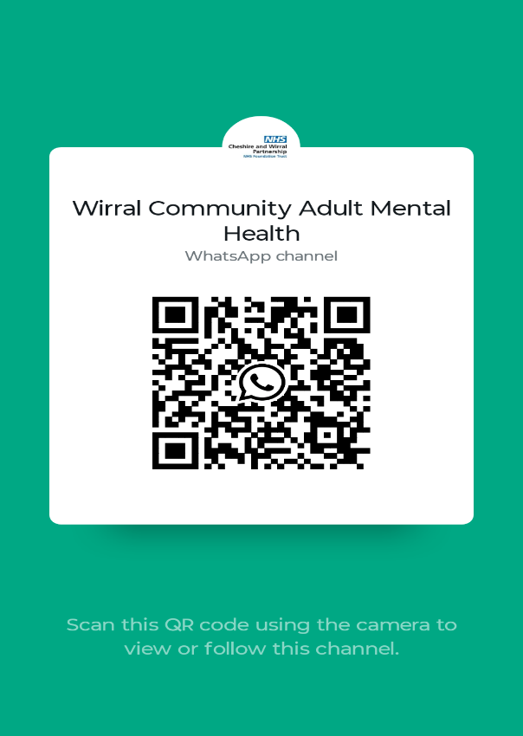

Please follow the Wirral Community Adult Mental Health Channel on WhatsApp for information, news on events in your community and wellbeing tips

Please follow the Wirral Community Adult Mental Health Channel on WhatsApp for information, news on events in your community and wellbeing tips

