USEFUL CONTACTS
Emma Hadwin, Practice Manager
Spital Surgery
1 Lancelyn Court Precinct
Spital Road
Bebington, Wirral, CH63 9JP (0151 334 4019)

Patient Advice Liaison service (PALS)
Wirral University Teaching Hospital NHS Foundation Trust
Arrowe Park Road , Upton,
Wirral CH49 5PE (0151 643 5305)

Wirral Integrated Care Board
Corporate Team, NHS Wirral ICB
5th Floor, Marris House
Hamilton Street, Birkenhead, CH41 5AL
https://www.cheshireandmerseyside.nhs.uk/contact/complaints/

NHS Cheshire and Merseyside
Patient Experience Team
No.1 Lakeside, 920 Centre Park Square
Warrington, WA1 1QY
0800 132 996
Or enquiries@cheshireandmerseyside.nhs.uk

Care Quality Commission
Citygate, Gallowgate
Newcastle Upon Tyne NE1 4PA
03000 616161 or http://www.cqc.org.uk/contact-us

Part of delivering a good service is knowing what we do well, so we would be very grateful for any positive feedback you have too. Please let us know if you have any compliments or suggestions about our service or standard of care.


RESOLVING YOUR PROBLEMS
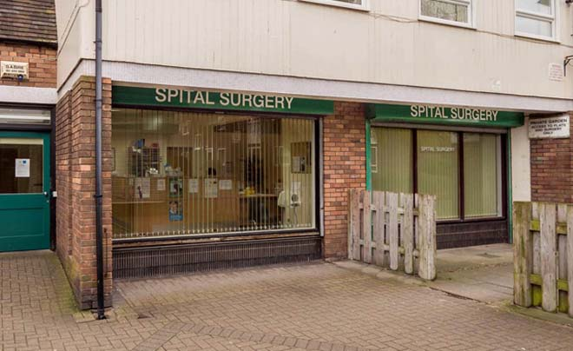
SPITAL SURGERY
“We aim to provide high quality, easily accessible, patient-centred medical care”
Telephone 0151 334 4019
Email cmicb-wi.gatekeeper-n85617@nhs.net
Website www.spitalsurgery.nhs.uk

It is our aim at all times to provide our patients with a high standard of care and professionalism. If we ever fall short of achieving this then we want to hear about it. If you are in any way dissatisfied with the service which you have received from any member of the Practice Team, our Complaints procedure is there to resolve the matter if it cannot be done informally.
How to raise your concerns
We hope that issues can be resolved easily and quickly, at the time they arise and with the person concerned. If you feel that our service can be improved we encourage you to make constructive suggestions, preferably in writing to Emma Hadwin, the Practice Manager.
If your concern is of a personal nature and cannot be resolved informally, please let us have details as soon as possible. This can be done in writing either to Dr Athan Simopoulos, senior partner, or Emma Hadwin, Practice Manager, or by making an appointment with Emma Hadwin, who will explain the complaints procedure to you, and will ensure that your complaint is dealt with promptly and professionally.
What we will do
On receipt of your formal complaint:
- We will provide you with an acknowledgement within two working days
- We will investigate the matter fully and respond within reasonable timescales, usually within ten days
- This may be in writing, or if agreeable to all parties, at a meeting with the people concerned

During our investigation we shall aim to:
- Find out what happened and what went wrong
- Make sure that you receive an apology where appropriate
- Identify what we can do to make sure that it does not happen again
Please note, should you make a complaint or claim, we may need to provide information about you, and treatment you have received, to insurers, indemnifiers or legal advisers when necessary.
Complaining on behalf of someone else
Please note that we are obliged to keep strictly to the rules of patient confidentiality. If you are complaining on behalf of someone else, we have to be sure that you have their permission to do so. A note signed by the person concerned will be required, unless they are unable to due to illness or disability. We comply fully with the General Data Protection Regulation 2018.
Complaining to NHS Cheshire and Merseyside
We hope at all times to be able to resolve issues within the Practice through the procedures described. However, if you do not wish to approach the practice directly you can contact NHS Cheshire and Merseyside or the Care Quality Commission if you are dissatisfied with the outcome of our investigation. A list of contacts can be found on the back of this leaflet.
Ombudsman
If you have not received a satisfactory response from this practice, your local Clinical Commissioning Group or NHS England, you can then refer your complaint to the Parliamentary and Health Service Ombudsman. You can call the Ombudsman’s helpline on 0345 015 4033, write to them at: The Health Service Ombudsman, Millbank or email: phso.enquiries@ombudsman.org.uk

